

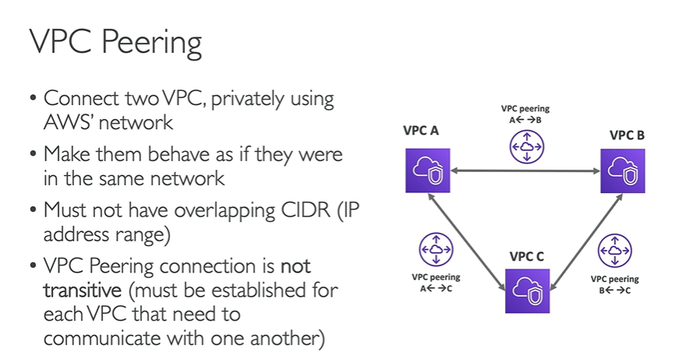

**NOTE:** If B is peered with A and A is peered with C, C still can’t talk to B and will have to be peered before they could talk.